<<<<

**WeSSun (TC-FTC) Technology**

**Macro – M130 - TESTING**

[Macro Manual]

Authors : SEENSO date : 01.04.2021

Technical References

|  |  |
| --- | --- |
| Project Acronym | WEDISTRICT |
| Project Title | *Smart and local reneWable Energy DISTRICT heating and cooling solutions for sustainable living* |
| Project Coordinator | ACCIONA |
| Project Duration | October - 19 / March – 23 (42 months) |

|  |  |
| --- | --- |
| Deliverable No. |  |
| Dissemination level 1 | CO |
| Work Package | WP |
| Task |  |
| Lead beneficiary |  |
| Contributing beneficiary(ies) | All |
| Due date of deliverable | 05th October 2020 |
| Actual submission date |  |

1 PU = Public

PP = Restricted to other programme participants (including the Commission Services)

RE = Restricted to a group specified by the consortium (including the Commission Services)

CO = Confidential, only for members of the consortium (including the Commission Services)

|  |
| --- |
| Document history |

|  |  |  |  |
| --- | --- | --- | --- |
| V | Date | Author/Editor | Comments |
| V0.1 | 21/12/2020 | Ignasi Gurruchaga / SEENSO | Table of contents and scope of the macro’s manual |
| V0.2 | 17/02/2021 | Ignasi Gurruchaga / SEENSO | Review and adding contents |
| V0.3 | 19/05/2021 | Ignasi Gurruchaga / SEENSO | Review and adding contents |
| V0.4 |  |  |  |
| V1 |  |  |  |

# Executive Summary

The purpose of this document is to show the details of M130 macro, which represents a solar thermal system built under the WeSSun (also named in previous versions TC-FTC Tracking Concentrator with Fixed Tilt Collector) technology. This document presents a detailed description of macro operation, as well as the identification of its parameters, inputs, outputs and external files.

# Disclaimer

This publication reflects only the author's view. The Agency and the European Commission are not responsible for any use that may be made of the information it contains.

# Abbreviations

|  |  |
| --- | --- |
| Abbreviation | Description |
|  |  |
|  |  |
|  |  |
|  |  |
|  |  |
|  |  |
|  |  |

# Acronyms

|  |  |
| --- | --- |
| Acronym | Description |
| WeSSun | Tracking Concentrator with Fixed Tilt Collector Solar Thermal technology |
| IAM | Incidence Angle Modifier |

# Table of Contents

Executive Summary 4

Disclaimer 4

Abbreviations 5

Acronyms 5

Table of Contents 6

1 Introduction 7

1.1 Main purpose of the document 7

1.2 Nomenclature used in the document 7

1.3 Macros Programming Structure 7

1.4 Main Components 9

1.4.1 Components Description 9

1.5 Parameters, Inputs, Outputs, Results and External Files 11

1.5.1 Main Parameters 11

1.5.2 Inputs 15

1.5.3 Outputs 16

1.5.4 Results 16

1.5.5 External Files 17

2 Detailed Description 18

2.1 General Description. Scope, Energy and hierarchy 18

2.2 Control Description 19

2.3 WeSSun Technology Characterization Description 20

2.3.1 General Approach 20

2.3.2 Incidence Angle Modifiers. Transversal and Longitudinal planes 21

2.3.3 External data File 26

2.3.4 General Planes Definitions 27

2.3.5 Shadows 28

2.4 Mass and Energy Balance 29

3 Validation Cases 30

3.1 Transversal Longitudinal Angles and Shadow Validation 30

3.2 General Validation 32

3.3 Parametric Study 32

# Introduction

## Main purpose of the document

Expose a detailed description of the programming methodology of the M130 macro, which has the purpose of representing a solar thermal system under the WeSSun technology.

## Nomenclature used in the document

The nomenclature used in the programming of M130 macro has been based on nomenclature set in the present project. Based on this, the nomenclature applied to the identification of macro associated with the solar thermal system is M130X (where X is the index of macro within deck). On the other hand, the nomenclature applied to components within the macro is M130X_COMPO, where COMPO is the component’s name (for example, COL01, PI01, HX01, etc). Finally, the code applied to variables within the macro is M130X_COMPO_JJJJ, where in JJJJ, which is necessary to specify the characteristic parameter or variable name, and its respective address (In or Out) or additional information.

## Macros Programming Structure

A macro is a grouping of TRNSYS components that perform a certain task within a deck. This task consists of the representation of a part of a system (a collector subsystem, an accumulation subsystem, a heat or cold production subsystem).

In this case, M130 macro represents a thermal solar system under WeSSun technology, which consists of the incorporation of mobile reflectors to a thermal solar collector, whichever may be a Flat Plate Collector, an Evacuated Tube Collector or an Evacuated Tube Compound Parabolic Collector technology. Hence M130 macro represents a solar thermal collector and its movable one or two reflectors that result in a larger opening area as it can be seen in the following figure:

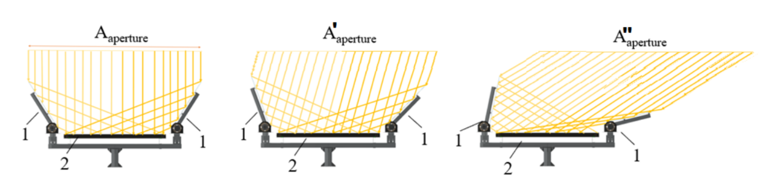



Figure 1. WeSSun Technology Concept

On the other hand, this macro considers a primary loop in which there is a heat transfer fluid, which receives thermal energy captured by collectors, and transfers to a secondary circuit throughout a counter-current heat exchanger.

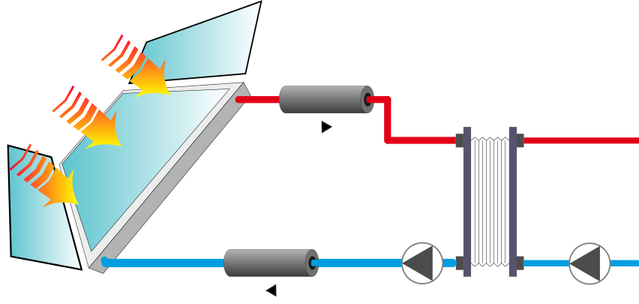  
Figure 2. Domain limits of Macro M130 of WeSSun Technology

The output of the secondary loop, which corresponds to the output of heat exchanger, is precisely the output of M130 macro. Likewise, the input to this loop, which corresponds to the input of heat exchanger, is one of the inputs of the macro, and is associated with a thermal storage system, which in this case is not part of this macro and belongs to another macro (M210 or other possible connections).

From the other side, there is the other main macro input, which is associated with the meteorological data provided by meteorological macro. Such as the macro considers shading effects, before this data is entered as input to the solar thermal collector system, it enters two types, which have the purpose of considering the shading generated by obstacles present on the horizon, and the shading generated by the same collector arrangement. The output of these types is shaded radiation, which enters as an input to the collector type. For simulation of operation of the solar thermal system, there is a multiple-choice control system within macro (match flow or fixed flow rate) that supervises the correct operation, and which decides when it is possible to enter operation, which occurs when two conditions are met: when there is demand and when there is a solar resource available.

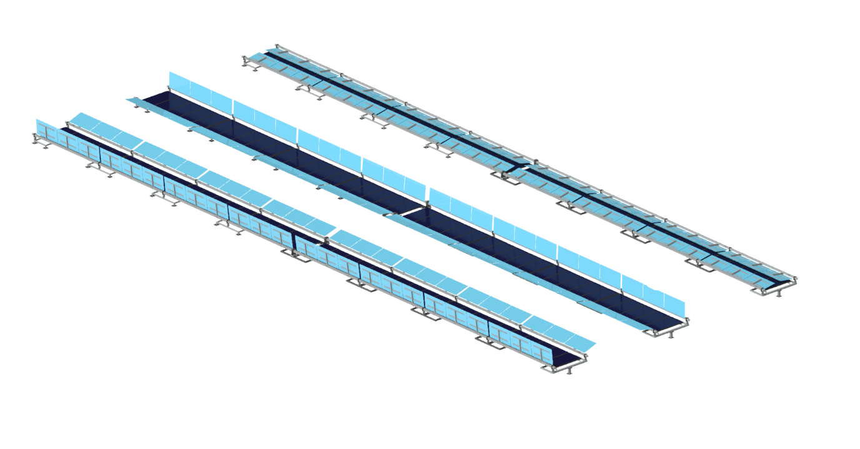

Figure 3. WeSSun Technology

## Main Components

Below, there is a list of main types / components un TRNSYS, and its associated DLLs that are part of M130:

|  |  |  |  |
| --- | --- | --- | --- |
| Type | Use | External File | DLL |
| 253 | WeSSun Technology | Yes. Must be developed from technology information. | Type253.dll |
| 709 | Pipes | No. | TRNDll.dll |
| 67 | Mask | Yes. Must be developed from site information. | TRNDll.dll |
| 204 | Shadow | No. | Type204.dll |
| 5b | Heat Exchanger | No. | TRNDll.dll |
| 110 | Pump | No. | TRNDll.dll |
| 65 | Online Plotter | No. | TRNDll.dll |
| 46 | Printegrator | No. | TRNDll.dll |
| 2 | Control | No. | TRNDll.dll |

### Components Description

The following is a brief description of the main components that comprise M130 macro.

#### Type 253 (M1300_COL01)

Type 253 represents the solar thermal field collector of WeSSun technology. This component describes a solar thermal collector for which the efficiency can be modelled with a linear or quadratic efficiency curve and the off-normal radiation effects can be treated with bi-axial incidence angle modifiers (IAMs). The user has the option of controlling the flow rate through the collector to maintain a desired outlet temperature. The capacitance (mass) of the collector may be accounted for in this model as well. The total collector array may consist of collectors connected in series and in parallel. The thermal performance of the total collector array is determined by the number of modules in series and the characteristics of each module. The user must provide results from a standard efficiency test versus a ratio of fluid temperature minus ambient temperature to radiation (ΔT/IT). The model assumes that the efficiency vs. ΔT/IT curve can be modelled as either a linear equation or a quadratic equation. The model will calculate the collector fin efficiency (F’), the collector loss coefficient, and the transmittance-absorptance product at normal incidence, based on the user-provided efficiency equation coefficients. Off-normal solar radiation is accounted for by utilizing bi-axial IAMs; the user must provide an external data file containing bi-axial IAM data. The bi-axial IAM data are useful for considering non-optically symmetric collectors.

Inlet parameters of this component correspond to the operation mode (i.e. constant flow or match flow for fixed outlet temperature) and WeSSun characteristics (collector’s aperture area, efficiency parameters, capacitance), number of WeSSun collectors arranged in series or parallel array, specific heat of the fluid, among others. As part of the input variables are the ambient temperature, the inlet temperature to the collector array, direct solar radiation, sky diffuse radiation, ground-reflected diffuse radiation, among others. Finally, for the WeSSun technology characterization a bi-axial IAM external data file is required.

The main results of this component correspond to the temperature and output mass flow of the working fluid, the thermal energy generated and the efficiency of the collector.

#### Type 67 (M1300_MSK)

Type67 reads a data file containing the angular heights of obstructions seen from an arbitrary opening, and outputs numbers that describe the time dependent on the shading of the opening. Among the outputs is a 0 or a 1 that corresponds to whether beam radiation is blocked or visible, and a number between 0 and 1 that gives the fraction of diffuse radiation visible from the opening. A 0 indicates that there is no diffuse radiation visible and a 1 indicates that all the diffuse radiation normally visible by the window is indeed visible.

The beam radiation calculation is made by deciding whether the sun is obstructed by an object at any given time, or not. The diffuse fraction estimation is done by integrating the shading effects seen by the window and dividing them by the view from the opening where no shading objects are present. With these non-dimensional numbers, the radiation that normally affects the opening can be adjusted to consider shading.

#### Type 204 (M1300_SHD)

This component determines incident radiation upon an array of collectors that are shaded from each other. The component considers fixed collectors in a sloped field, whose outputs are incident total, direct and diffuse radiation. This model assumes both the collectors and the field on which the collectors are located (the axes plane) are sloped in the direction of the array azimuth.

#### Type 5b (M1300_HX01)

Type 5 relies on an effectiveness minimum capacitance heat exchanger modelling. Under this assumption, the user is asked to provide the heat exchanger’s UA (overall heat transfer coefficient of exchanger) and inlet conditions. The model then determines if the cold (load) or the hot (source) side is the minimum capacitance side and calculates an effectiveness based upon the specified flow configuration and UA. The heat exchanger outlet conditions are then computed.

#### Type 110 (M1300_PU0X)

Type 110 represents a variable speed pump that is able to maintain any outlet mass flow rate between zero and a nominal value. Among the necessary parameters to be specified in this type are the nominal mass flow rate, the fluid specific heat, the consumption associated with operation, the motor heat loss fraction, among others. Regarding the input variables, these are the temperature and mass flow of the fluid entering pump, a control signal, the pump overall efficiency and the motor efficiency. No heat transfer from the pump to the fluid is considered.

#### Type 709 (M1300_PI0X)

This type models the thermal behavior of a fluid passing through a pipe using variable size segments in case longitudinal temperature discretization. This component is analogous to type 31; however, instead of asking the user to provide an overall UA value for the pipe and its insulation, the user is asked here to provide the physical characteristics of the pipe material, the fluid and the insulation material.

#### Type 2d (M1300_CON0X)

This type represents a controller that generates a control function $γ_{0}$ that can take a value equal to 0 or 1. This value is chosen according to the difference between the upper and lower temperatures (TH and TL) compared to two deadband temperature differences (Δ𝑇𝐻 and Δ𝑇𝐿). The new value of $γ_{0}$ depends on whether the input control signal is on or off ($γ_{i}$ =0 or 1). The controller is normally used with the output control signal ($γ_{0}$) connected to the inlet control signal (γ_i) giving a hysteresis effect. A high limit cut-out is included with the Type 2 controller. Regardless of the deadband conditions, the control function will be set to zero if the high limit condition is exceeded.

## Parameters, Inputs, Outputs, Results and External Files

### Main Parameters

Below are Parameters, Inputs, Outputs, Results and External Files considered in M130 macro:

| NAME | UNITS | DESCRIPTION | COMPONENTS |
| --- | --- | --- | --- |
| FLUID PARAMETERS |  |  |  |
|  |  |  |  |
| M1300_PriAntifree | % | Percentage of antifreeze |  |
| M1300_CpPri | kJ/kg.K | Fluid specific heat (primary loop) | M1300_WSS01 M1300_PU01 M1300_PI01 M1300_PI02 M1300_HX01 |
| M1300_RoPri | kg/m3 | Fluid density (primary loop) | M1300_PI01 M1300_PI02 |
| M1300_MuPri | kg/m.h | Fluid viscosity (primary loop) | M1300_PI01 M1300_PI02 |
| M1300_KPri | kJ/h.m.K | Fluid thermal conductivity (primary loop) | M1300_PI01 M1300_PI02 |
| M1300_CpSec | kJ/kg.K | Fluid specific heat (secondary loop) | M1300_PU02 M1300_HX01 |
| M1300_RoSec | kg/m3 | Fluid density (secondary loop) | M1300_PI01 M1300_PI02 |
| M1300_MuSec | kg/m.h | Fluid viscosity (secondary loop). Not used when deleting secondary pipes. |  |
| M1300_KSec | kJ/h.m.K | Fluid thermal conductivity (secondary loop). Not used when deleting secondary pipes. |  |
| HORIZON AND ARRAY SHADOW PARAMETERS |  |  |  |
| EQUATION |  |  |  |
| M1300_MSK_NumAngles | - | Number of surface angles | M1300_MSK01 |
| M1300_GrHrAzimuth | ° | Collector (¡¡¡ and Solar Field Ground !!!) Azimuth angle | M1300_SHD01 |
| M1300_GrHrSlope | ° | Ground slope versus horizontal | M1300_SHD01 |
| M1300_WSSHeightShadow | m | WESSUN Collector Height is Solar Collector Height plus the second reflector's height only for technologies with 2R. | M1300_SHD01 |
| M1300_WSSSlopeShadow | ° | Collector slope (WSS) for shadows' calculation. | M1300_SHD01 |
| M1300_WSS01_GndUsability | - | Ground usability (WSS). For M1300 internal use. |  |
| M1300_COL01_GndUsability | - | Ground usability (traditional collector).For M1300 internal use. |  |
| M1300_WSS01_Cheight | - | Collector height used to calculate shadows and ground usability. | M1300_WSS01 |
| M1300_WSSRowLen | m | Collector row length. Correlation points to a square solar field with a relative row separation (to heights' collector) equal to 3 and the restriction of a minimum row width of 60 [m]. | M1300_SHD01 |
| M1300_WSSNRows | - | Number of rows equal to solar field area divided by row width (length in shadow TRNSYS type nomenclature). | M1300_SHD01 |
| M1300_WSSRowSep | m | Collector row separation versus horizontal. Default correlation is based on the minimum distance for 12:00 solar time winter solstice, by two additional factors. For more detailed information see M1300 Manual Description | M1300_SHD01 |
| COLLECTOR PARAMETERS |  |  |  |
| EQUATION |  |  |  |
| PAR_STC | - | Solar Collector Technology included in external file. By default M1300 will include 7 different solar thermal collector technologies: 1-FPC, 2-GOT, 3-GOT_WeSSun_1R, 4-GOT_WeSSun_2R, 5-LIN, 6-LIN_WeSSun_1R, 7-LIN_WeSSun_2R, | M1300_WSS01 |
| PAR_KSOIL | - | Additional soiling factor for WESSUN reflectors | M1300_WSS01 |
| PAR_fRedDifusa | - | Concentrated diffuse radiation non-profitability factor for Reflectors. 0.8 means 20% profitability (by default). 1.0 means 0% profitability (isotropic) | M1300_WSS01 |
| M1300_WSS01_TCol_est | °C | Mean collector operation temperature. ### Only used for pre-sizing WESSUN collector area function ###. | M1300_WSS01 |
| M1300_EFF_COL | % | Mean collector efficiency estimation. ### Only used for pre-sizing WESSUN collector area function ###. | M1300_WSS01 |
| M1300_WSS01_Area | m2 | WESSUN Aperture area pre-sizing based on mean collector efficiency and beam and diffuse radiation. | M1300_WSS01 |
| M1300_WSS01_farea | - | WESSUN net aperture area factor. Relationship between net area and Aperture area regarding to non-useful ETC manifold-headers or PFC frames structures. | M1300_WSS01 |
| M1300_WSS01_Areau | m2 | WESSUN net Aperture area pre-sizing based on mean collector efficiency and beam and diffuse radiation. | M1300_WSS01 |
| M1300_ColHrSlope | ° | Collector slope versus horizontal | M1300_WSS01 |
| M1300_ColHrAzimuth | ° | Collector (and Solar Field Ground) Azimuth angle | M1300_WSS01 |
| M1300_COL01_Mode | - | WSS operating mode. Whether by-axial asymmetric IAM external files (mandatory for WESSUN technology) or IAM-K50 values will be used depends on this parameter. (Not used in last version) | M1300_WSS01 |
| M1300_WSS01_Nserie | - | Number of collectors in series. Maximum 2 serial connection by default. | M1300_WSS01 |
| M1300_WSS01_Nparalel | - | Number of parallel collectors | M1300_WSS01 |
| M1300_WSS01_Acol | m2 | Collector Area (No WSS). Manufacturer data. | M1300_WSS01 |
| M1300_WSS01_Ncol | - | Number of collectors | M1300_WSS01 |
| M1300_COL01_Cheight | m2 | Collector height.Manufacturer data. | M1300_WSS01 |
| M1300_WSS01_TestMode | - | Method in which the collector efficiency results are reported: 1 = As a function of the inlet temperature (common in the U.S.) 2 = As a function of the average temperature (common in Europe) 3 = As a function of the outlet temperature (common for air collectors) (2 by default). | M1300_WSS01 |
| M1300_WSS01_ThCap | kJ/K | Capacitance of Collector and the fluid it contains. | M1300_WSS01 |
| M1300_WSS01_ThCapUn | kJ/K.m2 | Capacitance of Collector per m2. (Fluid + Glass + Copper). | M1300_WSS01 |
| M1300_WSS01_Reflec | % | Percentage of reflected radiation in WESSUN Reflectors | M1300_WSS01 |
| M1300_WSS01_C | - | WESSUN concentration ratio. | M1300_WSS01 |
| M1300_COL01_a0 | - | Tested Collector Intercept efficiency a0 | M1300_WSS01 |
| M1300_WSS01_a0 | - | WESSUN Collector Intercept efficiency a0 | M1300_WSS01 |
| M1300_COL01_a1 | W/m2.K | Tested Collector 1st order loss coefficient (a1) | M1300_WSS01 |
| M1300_WSS01_a1 | kJ/h.m2.K | WESSUN Collector 1st order loss coefficient (a1) | M1300_WSS01 |
| M1300_COL01_a2 | W/m2.K2 | Tested Collector 2nd order loss coefficient (a2) | M1300_WSS01 |
| M1300_WSS01_a2 | kJ/h.m2.k2 | WESSUN Collector 2nd order loss coefficient (a2) | M1300_WSS01 |
| M1300_WSS01_Mtest | kg/h | Tested flow rate per unit area | M1300_WSS01 |
| M1300_COL01_IAMK50 | - | IAM K50 | M1300_WSS01 |
| M1300_COL01_IAM1 | - | 1st-order IAM (b0). Only used in non-WESSUN technologies. | M1300_WSS01 |
| M1300_COL01_IAM2 | - | 2nd-order IAM (b1). Only used in non-WESSUN technologies. | M1300_WSS01 |
| M1300_WSS01_DataTrans | - | Number of transverse IAM data points | M1300_WSS01 |
| M1300_WSS01_DataLong | - | Number of longitudinal IAM data points | M1300_WSS01 |
| M1300_WSS01_CtFRMin | kg/h | The minimum flow rate through the entire solar collector array that can be achieved when the pump is operating. | M1300_WSS01 |
| M1300_WSS01_MPAC | kg/h.m2 | The maximum flow rate through the entire collector array per unit area. | M1300_WSS01 |
| M1300_WSS01_Control | - | The type of flow-control that will be used for the primary loop control:  0-Fixed Flow Rate.   1-Match-flow Rate for desired temperature T storage (x_M1300_CON02_Thigh, M1300_TAcuHigh) + 1ºC  2-Match-flow Rate for desired temperature M1300_WSS01_Tset | M1300_WSS01 |
| M1300_WSS01_Tset | °C | Desired temperature for matchflow mode M1300_WSS01_Control = 2 | M1300_WSS01 |
| PIPE PARAMETERS |  |  |  |
| EQUATION |  |  |  |
| M1300_PI0102_Loc |  | Pipe location: 0=External 1=Internal 2=Buried | M1300_PI01 M1300_PI02 |
| M1300_PI01_Di | m | Inside diameter | M1300_PI01 M1300_PI02 |
| M1300_PI01_e | m | Pipe thickness. Based on tabulated data, a linear correlation is obtained by using the polyfit function in the python program. For more information, see annexes. | M1300_PI01 M1300_PI02 |
| M1300_PI01_Do | m | Outside diameter | M1300_PI01 M1300_PI02 |
| M1300_PI01_Kpi | kJ/h.m.K | Pipe thermal conductivity | M1300_PI01 M1300_PI02 |
| M1300_PI01_Insth | m | Insulation thickness. Based on tabulated data, a linear correlation is obtained by using the polyfit function in the python program. For more information, see annexes. | M1300_PI01 M1300_PI02 |
| M1300_PI01_Insk | kJ/h.m.K | Conductivity of insulation | M1300_PI01 M1300_PI02 |
| M1300_PI01_L | m | Total pipe length. Forward and Return. | M1300_PI01 M1300_PI02 |
| M1300_PI01_L2 | m | Pipe length oneway. | M1300_PI01 M1300_PI02 |
| HEAT EXCHANGER PARAMETERS |  |  |  |
| EQUATION |  |  |  |
| M1300_HX01_DTLM | °C | DTLM of the primary heat exchanger | M1300_HX01 |
| M1300_Qmax_solar | kJ/h | Total maximum solar power equal to Itmax * Area * collector intercept efficiency | M1300_HX01 |
| M1300_HX01_UA | kJ/h.°C | UA parameter associated with the primary heat exchanger | M1300_HX01 |
| PUMP PARAMETERS |  |  |  |
| EQUATION |  |  |  |
| M1300_PU01_MMin | kg/h | Minimum mass flow rate of pump | M1300_PU01 |
| M1300_PU01_M | kg/h | Nominal pump mass flow rate | M1300_PU01 |
| M1300_PU01_V | m3/h | Pump flow rate | M1300_PU01 |
| M1300_PU01_AP | Pa | Nominal pressure difference | M1300_PU01 |
| M1300_PU01_P | kJ/h | Rated power consumption | M1300_PU01 |
| M1300_PU02_M | kg/h | Rated flow rate | M1300_PU02 |
| M1300_PU02_V | m3/h | Pump flow rate | M1300_PU02 |
| M1300_PU02_AP | Pa | Nominal pressure difference | M1300_PU02 |
| M1300_PU02_P | kJ/h | Rated power consumption | M1300_PU02 |

### Inputs

| NAME | UNITS | DESCRIPTION | COMPONENT |
| --- | --- | --- | --- |
|  |  |  |  |
| SolZen | Degrees | Solar zenith angle | M1300_In1 |
| SolAz | Degrees | Solar azimuth angle | M1300_In1 |
| Tamb | °C | Ambient temperature | M1300_In1 |
| Tgr1 | °C | Ground temperature | M1300_In1 |
| TaTgr1mean | °C | Ambient Ground mean temperature | M1300_In1 |
| TaT20mean | °C | Ambient T20 mean temperature | M1300_In1 |
| Wind | m/s | Wind Velocity | M1300_In1 |
| Gtoth | kJ/hr.m2 | Total radiation on horizontal | M1300_In1 |
| Gbh | kJ/hr.m2 | Beam radiation on horizontal | M1300_In1 |
| Gdsh | kJ/hr.m2 | Sky diffuse radiation on horizontal | M1300_In1 |
| Gdgh | kJ/hr.m2 | Ground reflected diffuse radiation on horizontal | M1300_In1 |
| Gdh | kJ/hr.m2 | Total diffuse radiation on horizontal | M1300_In1 |
| Gb1 | kJ/hr.m2 | Beam radiation on surface-1 | M1300_In1 |
| Gds1 | kJ/hr.m2 | Sky diffuse radiation on surface-1 | M1300_In1 |
| Gdg1 | kJ/hr.m2 | Ground reflected diffuse radiation on surface-1 | M1300_In1 |
| InAn1 | Degrees | Incidence angle | M1300_In1 |
| Gtot1 | kJ/hr.m2 | Total radiation on surface-1 | M1300_In1 |
| Gb2 | kJ/hr.m2 | Beam radiation on surface-2 | M1300_In1 |
| Gds2 | kJ/hr.m2 | Sky diffuse radiation on surface-2 | M1300_In1 |
| Gdg2 | kJ/hr.m2 | Ground reflected diffuse radiation on surface-2 | M1300_In1 |
| InAn2 | Degrees | Incidence angle | M1300_In1 |
| Gtot2 | kJ/hr.m2 | Total radiation on surface-2 | M1300_In1 |
| M1300_TIn2 | ºC | Cold side return temperature | M1300_In2 |
| M1300_MIn2 | kg/h | Cold side return flow rate | M1300_In2 |
| M1300_CON02_Thigh | ºC | Cold side storage highest temperature | M1300_In2 |
| M1300_CON02_Tlower | ºC | Cold side storage lowest temperature | M1300_In2 |

### Outputs

|  |  |  |  |
| --- | --- | --- | --- |
| NAME | UNIT | DESCRIPTION | COMPONENT |
| M1300_Ou2 | °C | Cold-side outlet temperature (HX01) | M1300_TOu2 |
| M1300_Ou2 | kg/h | Cold-side flow rate (HX01) | M1300_MOu2 |

### Results

| NAME | UNIT | DESCRIPTION | Int. | OP |
| --- | --- | --- | --- | --- |
| M1300_RES_Gth | MWh/h |  | Yes | No |
| M1300_RES_Gbh | MWh/h |  | Yes | No |
| M1300_RES_Gdsh | MW |  | Yes | No |
| M1300_RES_Gdgh | MW |  | Yes | No |
| M1300_RES_Gt1 | MW |  | Yes | No |
| M1300_RES_Gb1 | MW |  | Yes | No |
| M1300_RES_Gds1 | MW |  | Yes | No |
| M1300_RES_Gdg1 | MW |  | Yes | No |
| M1300_RES_Gt1Sh67 | MW |  | Yes | No |
| M1300_RES_Gb1Sh67 | MW |  | Yes | No |
| M1300_RES_Gds1Sh67 | MW |  | Yes | No |
| M1300_RES_Gdg1Sh67 | MW |  | Yes | No |
| M1300_RES_Gt1Sh6730 | MW |  | Yes | No |
| M1300_RES_Gb1Sh6730 | MW |  | Yes | No |
| M1300_RES_Gds1Sh6730 | MW |  | Yes | No |
| M1300_RES_Gdg1Sh6730 | MW |  | Yes | No |
| M1300_RES_QWSS | MW |  | Yes | No |
| M1300_RES_QLsPi01 | MW |  | Yes | No |
| M1300_RES_QLsPi02 | MW |  | Yes | No |
| M1300_RES_QHx1 | MW |  | Yes | No |
| M1300_RES_WPU01 | MW |  | Yes | No |
| M1300_RES_WPU02 | MW |  | Yes | No |
| M1300_RES_W | MW |  | Yes | No |
| M1300_RES_dQPi1 | MWh |  | No | No |
| M1300_RES_dQPi2 | MWh |  | No | No |
| M1300_RES_QOu | MW |  | Yes | No |
| M1300_RES_EB | MW |  | Yes | No |
| M1300_RES_eta_col | - |  | - | Yes |
| M1300_RES_WSS_Tou | ºC |  | - | Yes |
| M1300_RES_WSS_Tin | ºC |  | - | Yes |
| M1300_RES_TIn2 | ºC |  | - | Yes |
| M1300_RES_TOu2 | ºC |  | - | Yes |
| M1300_RES_MIn2 | kg/h |  | - | Yes |
| M1300_RES_PU01Rev | - |  | - | Yes |
| M1300_RES_PU02Rev | - |  | - | Yes |
| M1300_RES_MPu01 | kg/h |  | - | Yes |
| M1300_RES_WSS01_Area | m2 |  | No | Yes |
| M1300_RES_PU01_AP | Pa |  |  |  |
| M1300_RES_PU02_AP | Pa |  |  |  |
| M1300_RES_OTWSS | h |  |  |  |
| M1300_RES_rauxWSS | - |  |  |  |
| M1300_RES_FEC1..15 | kWh |  |  |  |

### External Files

|  |  |
| --- | --- |
| NAME | COMPONENT |
| Defmask67.dat | M1300_MSK |
| IAM_GOT.txt | M1300_WSS01 |
| IAM_GOT_WeSSun_1R.txt | M1300_WSS01 |
| IAM_GOT_WeSSun_2R.txt | M1300_WSS01 |
| IAM_LIN.txt | M1300_WSS01 |
| IAM_LIN_WeSSun_1R.txt | M1300_WSS01 |
| IAM_LIN_WeSSun_2R.txt | M1300_WSS01 |

# Detailed Description

## General Description. Scope, Energy and hierarchy

Macro’s operation is governed by two main data streams. The first one corresponds to meteorological data provided by meteorological macro M100, which is linked to the primary circuit operation throughout *M1300_In1* and *M1300_Ou1* equations, and the second one corresponds to demand data, which is associated with the thermal energy supply circuit, and is linked throughout *M1300_In2* and *M1300_Ou2* equations. Depending on the behavior of both, the WeSSun solar thermal system will or will not enter operation. In particular, the solar thermal system will operate when there is demand and when there is a solar resource available simultaneously.

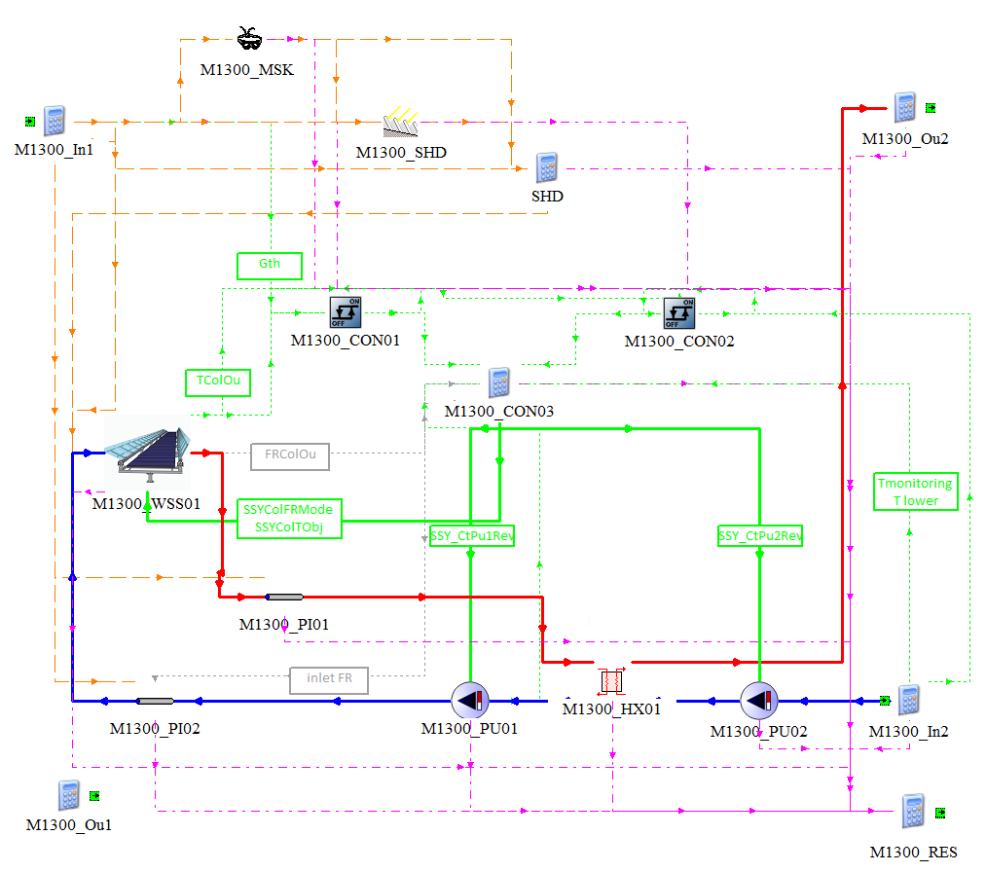

Figure 4. Macro M130

To describe the macro operation, it will be assumed that behavior of both information sources (radiation and demand data) give way to the solar thermal system operation. Taking this into account, we proceed to describe first the solar radiation path before it effectively affects the collectors; then we will describe the primary circuit operation, and finally, the secondary circuit operation.

Radiation data comes from the meteorological macro M100, which contains different meteorological data such as ambient temperature, beam solar radiation, sky diffuse radiation, ground-reflected diffuse radiation and the incident angle over the collector surface and over terrain of the solar field; furthermore: the solar azimuth angle, the solar zenith angle, among others. All data associated with the solar radiation is entered into the M1300_MSK (Type 67) component, which is intended to include as a factor the possible obstruction generated by elements on the horizon that may affect the arrival of radiation to collectors. After considering this factor, the second one is added, which is associated with the shading generated by the collector array. Such consideration is made in M1300_SHD (Type 204). Once both factors have been considered, the unshaded radiation data is entered as input to the solar thermal system represented by M1300_WSS01 (Type 253).

The solar collector captures the solar radiation, and transforms to thermal energy into the working fluid, which increases in temperature as it passes through the collector array. The primary loop, together with forward and return pipes M1300_PI01 and 01 (Type 709) and variable speed pump M1300_PU01 (Type 110) make up the primary circuit. A heat exchanger M1300_HX01 (Type 5b) transfers primary loop thermal energy to the secondary loop whose fluid increases its temperature, and which includes a variable speed pump M1300_PU01 (Type 110). This circuit can be connected to or a thermal storage system, either to the consumer circuit.

With respect to the control system, this will control the operation of the pumps of the primary and secondary circuit, which would operate simultaneously if there is a solar resource available and demand requirement. In the following section there is a detailed description regarding to control.

## Control Description

To enable solar system operation two conditions must be meet. The first one corresponds to radiation, which is evaluated in order to determine if it is within a profitable range. If the incident radiation is within this range, the system has the option to start operating. For the system to start operating, it is necessary to analyze the second variable, which is related to the difference between the maximum temperatures of the primary and secondary loop. When the difference between these temperatures is within the established range, and when the radiation levels are appropriate, the system will start operating.

The solar system can operate either at fixed flow or variable/match flow, as specified in the following implemented parameters and equations:

1. Fixed Flow Rate.
2. Match-flow rate for accomplish desired variable storage temperature.
3. Or match-flow rate for desired fixed temperature.

|  |  |  |  |
| --- | --- | --- | --- |
|  | Fixed Flow Rate | Match Flow desired variab. storage T | Match Flow desired fixed temperature |
| Parameters |  |  |  |
| M1300_WSS01_Control | 0 | 1 | 2 |
| Equation M1300_CON03 |  | | |
| M1300_WSS01_MMode | 0 | 2 | 2 |
| M1300_WSS01_TObj | - | M1300_TAcuHigh + M1300_HX01_DTLM + 1 | M1300_WSS01_Tset |

## WeSSun Technology Characterization Description

### General Approach

In the present section there is a description how WeSSun technology is characterized in M130.

WeSSuN solar technology is represented in M130 TRNSYS’ macro as an **aperture area** solar thermal collector for which the efficiency can be modelled with a linear or quadratic efficiency curve and the off-normal radiation effects can be treated with bi-axial non-symmetric incidence angle modifiers (IAMs).

WeSSun aperture area can be defined as the parallel surface to solar collector, either ETC or FPT or other). WeSSun concentration ratio is the ratio between WeSSun aperture area and collector’s area. Collector’s area can be either aperture’s, net or brute area, but must be consistent with efficiency collectors’ parameters and beyond economical capital costs in order to maintain coherence.

$$C_{WSS}= \frac{A_{WSS,aperture}}{A_{COL,*}}$$



Aaperture

Aaperture

Figure 5. WeSSun Aperture area definition

Internally it is stablished a WeSSun net aperture area factor, 0.9, which is the relationship between net area and aperture area regarding to non-useful ETC manifold-headers or FPC frames structures.

The thermal performance of the total WeSSun solar thermal array is determined by the number of WeSSun modules in series and the characteristics of each WeSSun module, which likewise are determined from its **standard efficiency test parameters**: a0,WSS, a1,WSS, and a2,WSS and IAM external data files.

These standard WeSSun efficiency parameters can be obtained from the standard solar collector efficiency parameters (a0,COL, a1,COL, and a2,COL) depending mainly in concentration WeSSun ratio, $C_{WSS}$ as it is represented in the following equations:

$$a_{0, WSS}= a_{0,COL}·\frac{1+ ρ·\left(C_{WSS}-1\right)}{C_{WSS}}· \left[1- δ·\left(1- \frac{1}{C_{WSS}}\right)\right]$$

$$a_{1, WSS}= a_{1,COL}·\frac{1}{C_{WSS}}$$

$$a_{2, WSS}= a_{2,COL}·\frac{1}{C_{WSS}}$$

**Note**: where $ρ$ is the mirror reflectance and $δ$ the diffuse radiation fraction. The second term (between brackets) is implemented not in parameters but in TRNSYS internal equations as the diffuse radiation fraction is not a constant value. So, in practical terms the $a_{0, WSS}$ parameter equals to $a_{0, WSS}= a_{0,COL}·\frac{1+ ρ·\left(C_{WSS}-1\right)}{C_{WSS}}$

### Incidence Angle Modifiers. Transversal and Longitudinal planes

Regarding to IAM, WeSSun technology characterization requires biaxial non-symmetric Incidence Angle Modifiers (IAM) to be provided in an external data file (see the section “External Data File” of this chapter for more information) in order to represent the asymmetric optical behavior.

These IAM are provided in longitudinal and transversal directions for different longitudinal and transversal incidence angles.

* The transversal incidence angle is measured in a plane that is perpendicular to the collector plane and contains the collector azimuth. The corresponding IAM is referred to as the transversal IAM, or altitude modifier.
* The longitudinal incidence angle is measured in a plane that is perpendicular to both the collector aperture and the transversal plane. The corresponding IAM is referred to as the longitudinal IAM, or azimuthal modifier.

**Note**: Despite this criteria contradicts other biaxial IAM collector types in TRNSYS is more adapted to WeSSun geometry.

 

Figure 6. WeSSun Transversal and Longitudinal planes definition for IAM biaxial characterization.

Transversal and longitudinal angles are calculated internally in M1300_WSS01 (Type 253) through the following expressions:

$$θ=arcos \left[\cos{θ_{s}}· \cos{β}+ \sin{θ_{s}}· \sin{β}·\cos\left(∅_{s}-γ\right) \right]$$

$$θ_{long}=arctan\left(\frac{\sin{θ_{s}}·\sin\left(∅_{s}-γ\right)}{\cos{θ}}\right)$$

$$θ_{trans}=- arctan\left(\tan{θ_{s}}· cos\left(γ- ∅_{s}\right)\right)+ β$$

Where:

* $θ$, Incidence Angle
* $θ_{s}$, Solar zenith
* $∅_{s}$, Solar azimuth
* $γ$, Surface azimuth
* $β$, Surface slope

Derived from Theunissen et Al.- 1985 - Solar transmittance characteristics of ETC with diffuse back reflectors, John A. Duffie_ William A. Beckman_ Nathan Blair - Solar Engineering of Thermal Processes, Photovoltaics and Wind-John Wiley & Sons (2020).

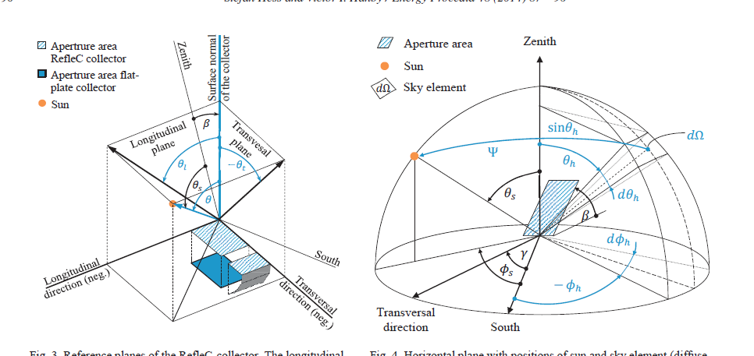

Figure 7. WeSSun transversal and longitudinal angles from Hess S. – 2013 – Collector simulation model with dynamic incidence angle modifier for anisotropic diffuse irradiance

When facing towards different azimuthal angles, the whole aperture area, and its optically transversal and longitudinal IAM characterization rotates simultaneously. The following examples shows how transversal and longitudinal angles are evaluated.

|  |
| --- |
| **North Hemisphere. Azimuth = 0**  Longitudinal  Transversal  -  +  -  +  Longitudinal  Theta Trans  Theta Long  azimuth  equator |
| **Transversal angle from -90 ...-zenit…-90**  **Longitudinal angles from -90 to +90** |
|  |
| **North Hemisphere. Azimuth = -45 (facing east)**  Longitudinal  Transversal  -  +  -  +  Theta Trans  Theta Long |
| **Transversal angles from -90 to 90**  **Longitudinal angles from 90 to -90** |
|  |
| **North Hemisphere. Azimuth = 90 (facing west)**  Longitudinal  Transversal  -  +  -  +  Theta Trans  Theta Long |
| **Transversal angles from -90 to 90**  **Longitudinal angles form -90 ...-zenit…-90** |
|  |

Figure 8. WeSSun transversal and longitudinal angles depending on azimuthal orientation verified in TRNSYS.

### External data File

M1300_WSS01 (Type253) reads the biaxial incidence angle modifier (IAM) data from an external data file. These data are read and interpolated by subroutine DYNAMICDATA.

The data consists of between 2 and 100 values of incidence angles (in both directions) and modifiers.

<Transversal angle 1> <Transversal angle 2> etc. Nt values [0;90]

<Longitudinal angle 1> <Longitudinal angle 1> etc. Nl values [0;90]

<IAM 1 1> IAM for transv. angle 1, long. angle 1

<IAM 1 2> IAM for transv. Angle 1, long. angle 2

...

<IAM 1 Nl> IAM for transv. angle 1, long. angle Nl

Here attached an example:

! 35 13

-85 -80 -75 -70 -65 -60 -55 -50 -45 -40 -35 -30 ….

-90 -75 -60 -45 -30 -15 0 15 30 45 60 75 ….

0 ! IAM for transv. angle -85, long. angle -90

1.706 ! IAM for transv. angle -85, long. angle -75

3.412 ! IAM for transv. angle -85, long. angle -60

3.7122 ! IAM for transv. angle -85, long. angle -45

3.9908 ! IAM for transv. angle -85, long. angle -30

3.9318 ! IAM for transv. angle -85, long. angle -15

4.0946 ! IAM for transv. angle -85, long. angle 0

3.9318 ! IAM for transv. angle -85, long. angle 15

3.9908 ! IAM for transv. angle -85, long. angle 30

3.7122 ! IAM for transv. angle -85, long. angle 45

3.412 ! IAM for transv. angle -85, long. angle 60

1.706 ! IAM for transv. angle -85, long. angle 75

0 ! IAM for transv. angle -85, long. angle 90

0 ! IAM for transv. angle -80, long. angle -90

Figure 9. WeSSun IAM External File format.

### General Planes Definitions

* Ground plane, the plane where the diffuse ground radiation is reflected.
* Collector plane, the plane which contains WeSSun aperture area.
* Transversal collector’s angle plane is perpendicular to Collectors’ plane and contains the collector azimuth angle. *ColHrAzimuth* is the angle between the Transversal collector’s angle plane and equator, 90 in following picture). Transversal collector’s angle plane contains transversal angles.
* Longitudinal collector’s angle plane is perpendicular to Transversal collector’s angle plane and Collector’s plane. Longitudinal collector’s angle plane contains longitudinal angles.

#### General EW Axis Tracking orientation

* Ground Plane, defined by: GrHrSlope, GrHrAzimuth.
* Collector Plane, could be defined relative to ground plane: ColGrSlope, ColGrAzimuth (normally =0, so GrHrAzimuth = ColHrAzimuth), or from absolute horizontal plane: ColHrSlope, ColHrAzimuth.

Figure 10a. WeSSun general EW Axis Tracking orientation.

#### General NS Axis Tracking orientation

* Ground Plane, defined by: GrHrSlope = 0, GrHrAzimuth = 90 in previous picture.
* Collector Plane, could be defined relative to ground plane: ColGrSlope, ColGrAzimuth (normally =0, so GrHrAzimuth = ColHrAzimuth = 90 in previous picture), or from absolute horizontal plane: ColHrSlope, ColHrAzimuth.

Figure 10b. WeSSun general NS Axis Tracking orientation.

### Shadows

#### Horizon Shadows – Type67

Horizon shadows are implemented through an external data file containing the angular heights of obstructions seen from an arbitrary reference point.

The beam radiation calculation is made by deciding whether the sun is obstructed by the defined external file at any given time, or not. The diffuse fraction estimation is done by integrating the shading effects seen by arbitrary reference point.

#### Array Shadows – Type204

Array shading of fixed collectors in a sloped field is considered through Type204 This model assumes both the collectors and the field on which the collectors are located are sloped in the direction of the array azimuth. This might be a limitation.

 Figure 11. Type204 possibilities and limitations of type 204

## Mass and Energy Balance

In this Macro the Mass balance only has one inlet and one outlet.

Energy balance has the useful energy from the collector systema as main inlet, while energy outflows consist in the energy leaving the system by the increase in the secondary circuit flow temperature, and the different heat losses in pipes.

Heat and mass balance are as by the following scheme:

$$QLsPi02$$



$$QPu02In$$

$$QPu01In$$

$$QLsPi01$$

$$QPTC01$$

$$QOu01$$

$$MB={\dot{m}}_{Out}-{\dot{m}}_{In}$$

$$EB=QPTC01+QPu01In+QPu02In-QOu01-QLsPi01-QLsPi02-\sum{dQ}$$

# Validation Cases

## Transversal Longitudinal Angles and Shadow Validation

As part of the validation process, the behavior of the Total Incidence Angle Modifier with which TRNSYS works was first studied. In fact, a graphical comparison was made between the behavior obtained by TRNSYS and the behavior obtained from an analytical approximation carried out by the team.

Below, different graphs are shown where the behavior obtained in TRNSYS and that obtained analytically can be observed.

|  |  |
| --- | --- |
|  |  |
| Figure 12. Case: Azimuth 0°, Slope 0°, Day January 6, LIN 2R. | |
|  |  |
| Figure 13. Case: Azimuth 0°, Slope 0°, Day April 9, LIN 2R. | |
|  |  |
| Figure 14. Case: Azimuth 0°, Slope 0°, Day June 2, LIN 2R. | |
|  |  |
| Figure 15. Case: Azimuth 0°, Slope 45°, Day January 6, LIN 2R. | |
|  |  |
| Figure 16. Case: Azimuth 0°, Slope 45°, Day April 9, LIN 2R. | |
|  |  |
| Figure 17. Case: Azimuth 0°, Slope 45°, Day June 2, LIN 2R. | |
|  |  |
| Figure 18. Case: Azimuth 45°, Slope 0°, Day January 6, LIN 2R | |
|  |  |
| Figure 19. Case: Azimuth 45°, Slope 0°, Day April 9, LIN 2R | |

All the graphs obtained in this analysis can be found in the file *Transv Long Angles and Shadow Validation.xlsx.*

As can be seen from the graphs displayed, the behavior of the total IAM coincides with what was expected.

## General Validation

Within the validation process, a particular case was studied that occurs at the spring equinox in the northern hemisphere (March 21st), where the angle of transverse incidence should be approximately constant. As it is possible to appreciate in the following graph, the behavior of the transverse angle coincides with the expected.

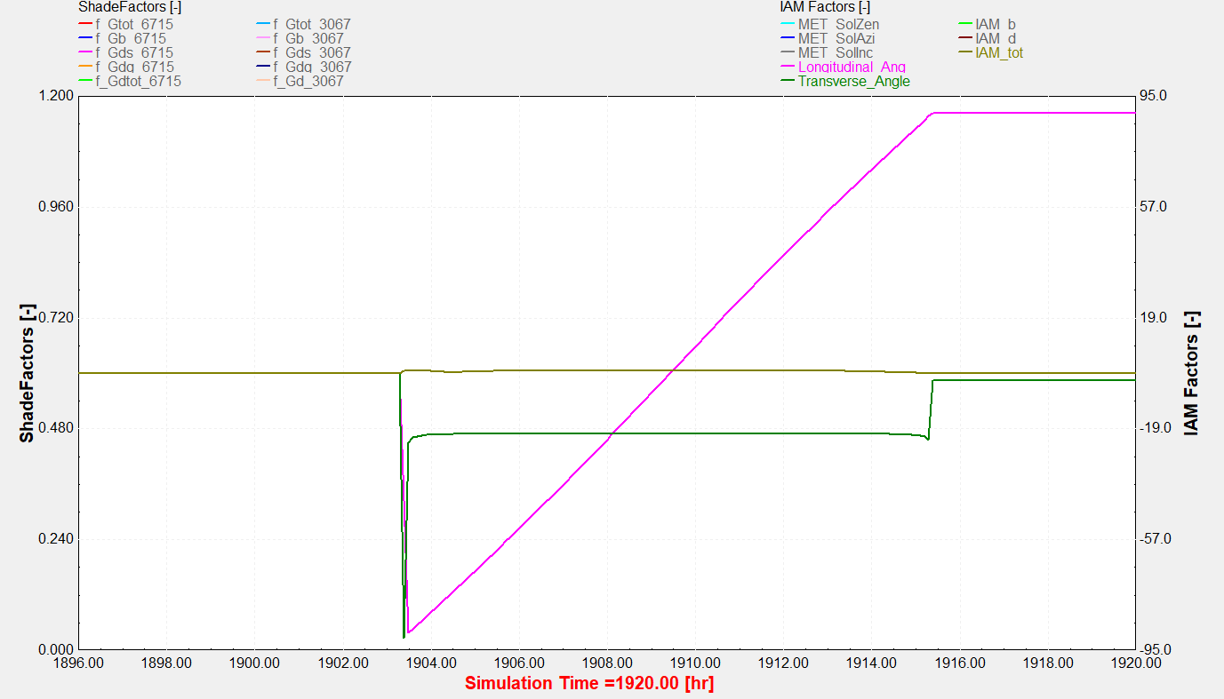

Figure 20. Behavior of transverse angle, longitudinal angle, and total IAM.

## Parametric Study

As part of the validation process, a parametric study was conducted for the M130 macro, considering the following technologies:

1. GOT
2. WeSSun - GOT 1 Reflector (GOT 1R)
3. WeSSun - GOT 2 Reflectors (GOT 2R)
4. LINUO
5. WeSSun - LINUO 1 Reflector (LIN 1R)
6. WeSSun - LINUO 2 Reflectors (LIN 2R)

The parameters analyzed for this part of the study were as follows:

1. Location
   1. Kobhaven
   2. Graz
   3. Barcelona
   4. Madrid
   5. Santiago
   6. Calama
2. Azimuth
   1. 0°
   2. 90° (applied only to GOT 2R / LIN 2R technologies)
3. Collector Slope
   1. When azimuth is zero (Orientation E-W), the slope corresponds to the absolute of latitude of the place under study.
   2. When azimuth is 90° (Orientation N-S), the slope corresponds to zero.
4. Return Temperature
   1. 50°C
   2. 80°C
   3. 110°C
   4. 140°C
   5. 170°C
   6. 200°C

The results obtained from this parametric study are contained in the file *Estudio Parametrico_T253v6_M1300_v20.xlsx*. The following are the main graphs obtained from the simulations performed:

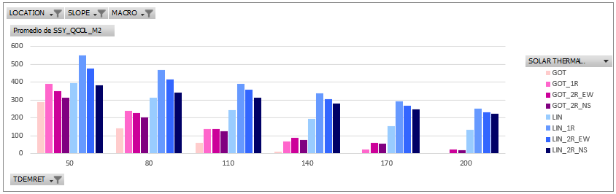

Figure 21. Solar Collector Production kWh/m2 – Kobhaven.

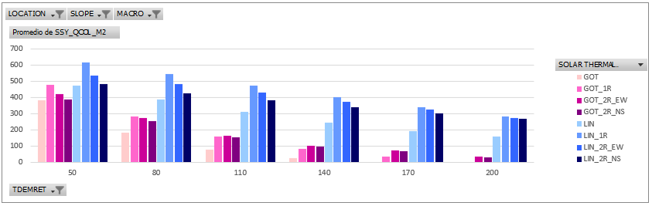

Figure 22. Solar Collector Production kWh/m2 – Graz.

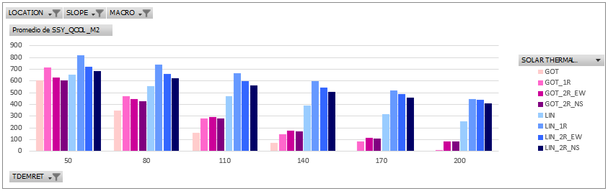

Figure 23. Solar Collector Production kWh/m2 – Barcelona.

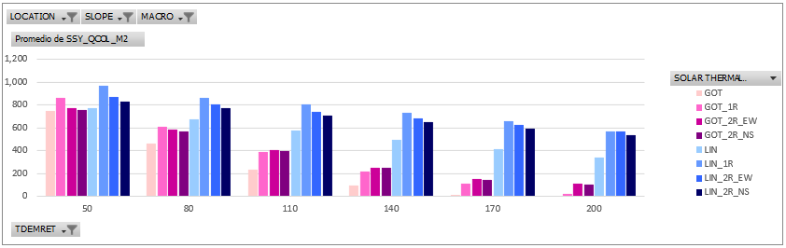

Figure 24. Solar Collector Production kWh/m2 – Madrid.

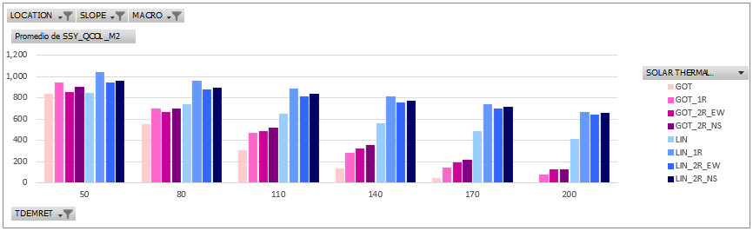

Figure 25. Solar Collector Production kWh/m2 – Santiago.

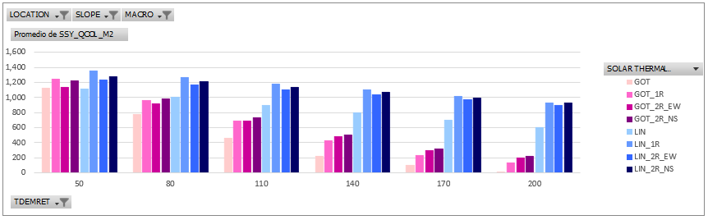

Figure 26. Solar Collector Production kWh/m2 – Calama.

In these graphs it is possible to appreciate the thermal production per square meter, differentiating by technology, location and return temperature. As can be seen, the technology with the highest associated production corresponds to LIN 1R in all locations. On the other hand, as the return temperature increases, production tends to decrease. Finally, when comparing between locations, the highest production is associated with Calama.

In addition to these results, a parametric analysis was performed for Madrid, using LINUO 1 Reflector technology. The variables analyzed were:

1. Diffuse radiation profitability factor (0% prof. 🡪 100% isotropic)
   1. 30% 🡪 0.7
   2. 25% 🡪 0.75
   3. 15% 🡪 0.85
   4. 10% 🡪 0.9
   5. 5% 🡪 0.95
   6. 0% 🡪 1.0
2. Ratio of accumulation volume/m2
   1. 60
   2. 70
   3. 80
   4. 90
   5. 100
   6. 110
   7. 120
   8. 130
3. Collector slope
   1. 0°
   2. 10°
   3. 20°
   4. 30°
   5. 40°
   6. 50°
   7. 60°
   8. 70°

The results obtained from this parametric study are contained in the file mentioned above.

The behavior of these results is shown below:

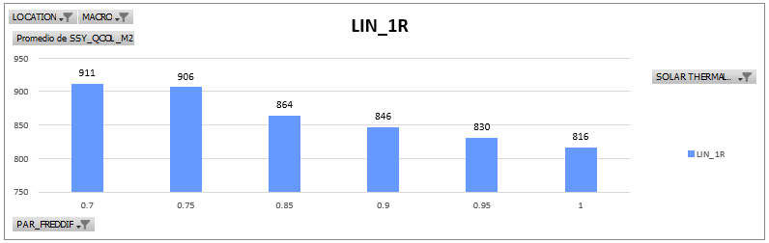

Figure 27. Solar collector production in kWh/m2 obtained from varying the Diffuse Factor.

As can be seen from this graph, as the diffuse radiation profitability factor increases, the production per square meter is higher.

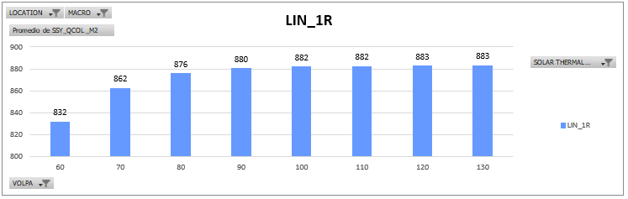

Figure 28. Solar collector production in kWh/m2 obtained from varying the ratio of accumulation volume/m2.

On the other hand, as the ratio of accumulation volume per square meter increases, production increases, until it reaches a stagnation point where production does not increase.

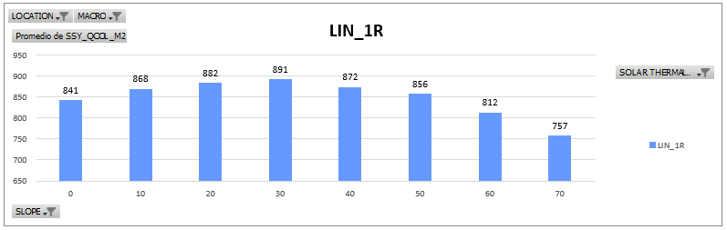

Figure 29. Solar collector production in kWh/m2 obtained from varying the slope.

Also, from Figure 10 the production per square meter has an optimum as the slope varies, an optimum that is not necessarily attributed to a slope equal to the latitude of the site.

Another parametric study that was carried out consisted of evaluating the incidence of collector loss factors, factors that affect the IAMs of each technology. In this case, the LINUO 2 Reflectors technology was specifically evaluated, where the following was obtained for Madrid:

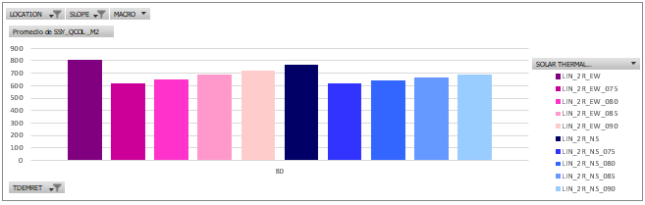

Figure 30. Solar collector production in kWh/m2 obtained from varying the loss factors.

As can be seen, the loss factors affect proportionally the production level of the technology studied.

All the results of this study can be found in the file *Estudio Parametrico_M1300_5LIN_2R.xlsx.*

Finally, a parametric study was performed by varying the same parameters worked previously, but this time a comparison was made between the WeSSun technology and the Parabolic Trough Collector-Fresnel technologies. The results obtained are contained in the file *Parametric Study_v2_M1300_M1200_M1200_plus_other_results*.

A comparative table of the results obtained for the different concentration technologies and for the different locations considered, is shown below. As it is possible to appreciate, here it is compared for each location, the different technologies with respect to the one with the highest production per square meter.

